**USE CASE DIAGRAM :-**

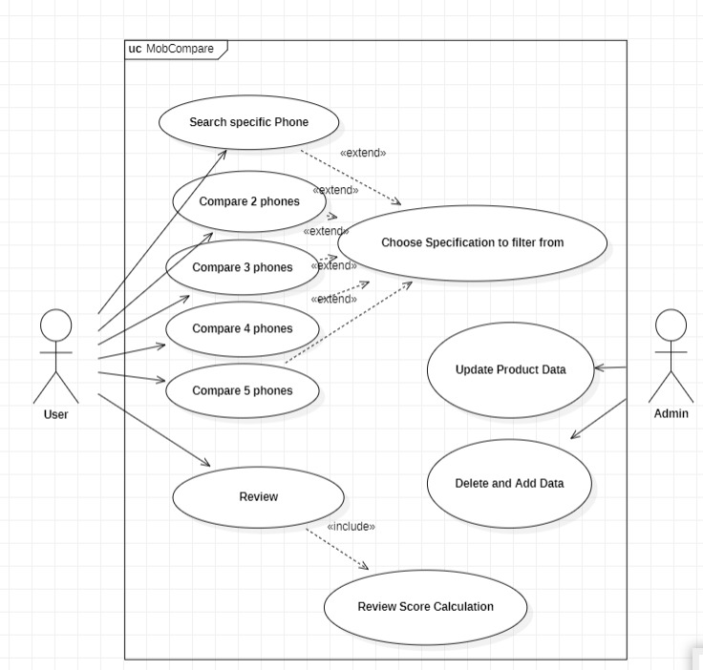

**ACTIVITY DIAGRAM (USER)**

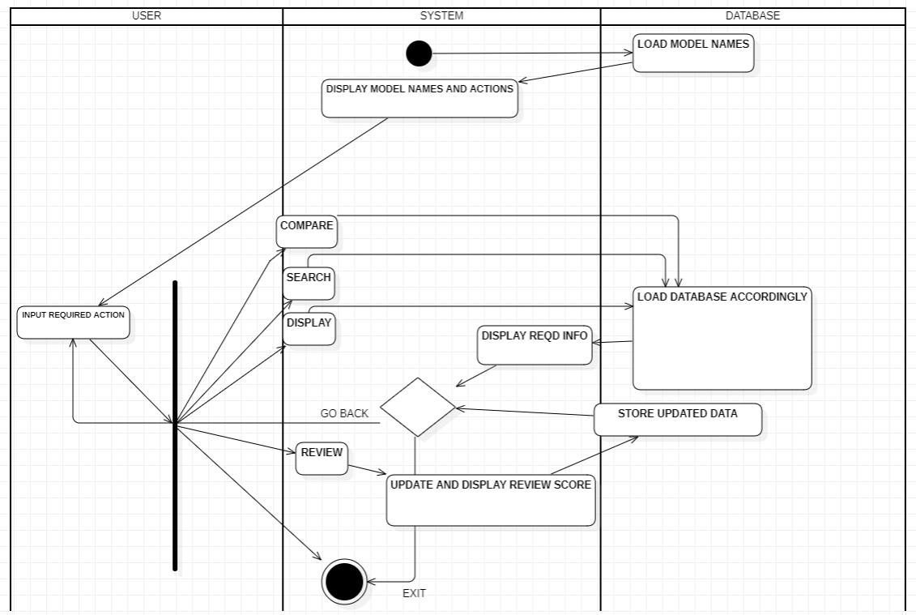

**ACTIVITY DIAGRAM (ADMIN) :-**

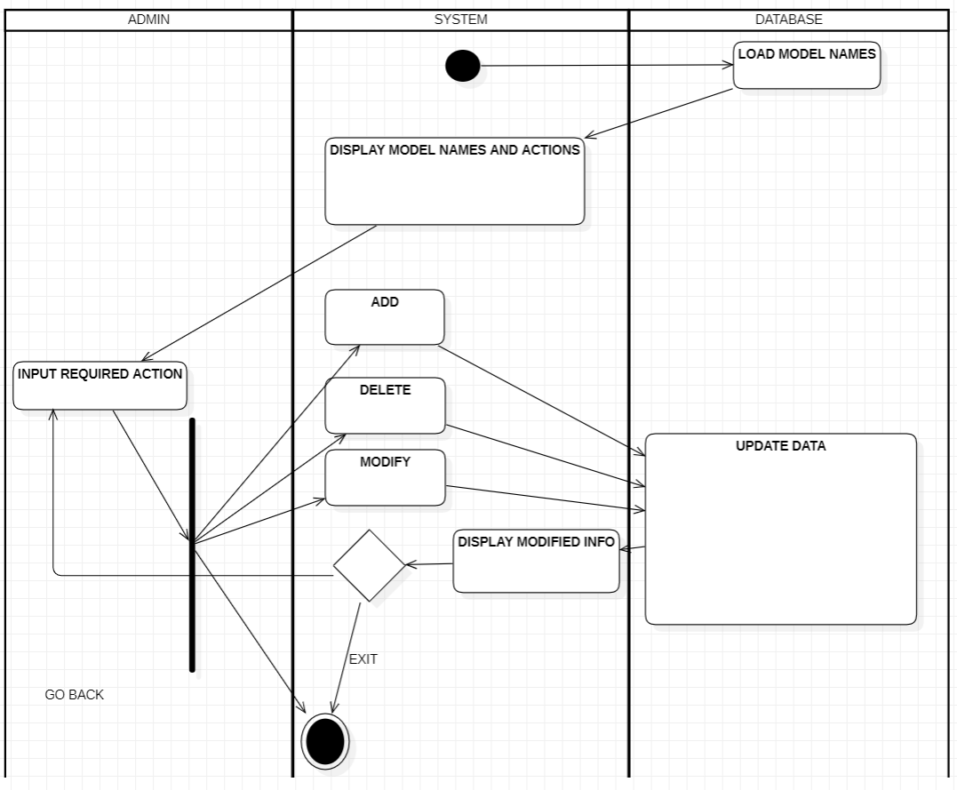

**DEPLOYMENT DIAGRAM :-**

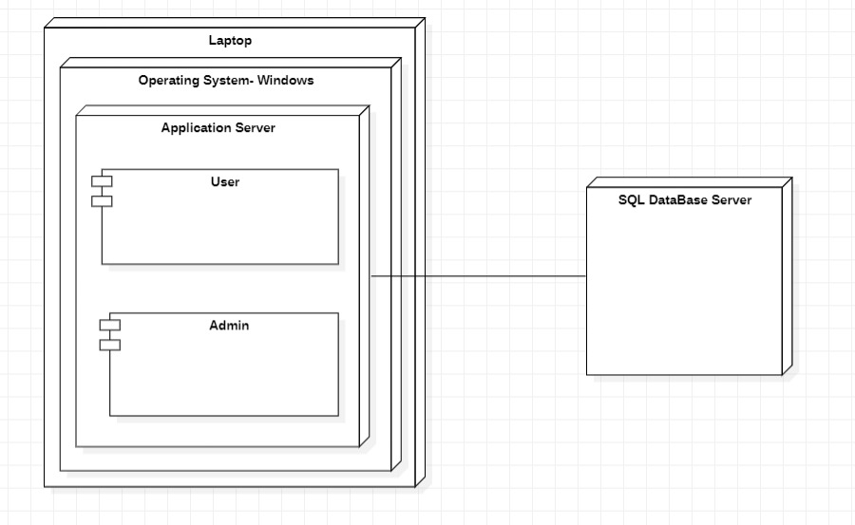

USE CASE DIAGRAM (FUTURE)

